

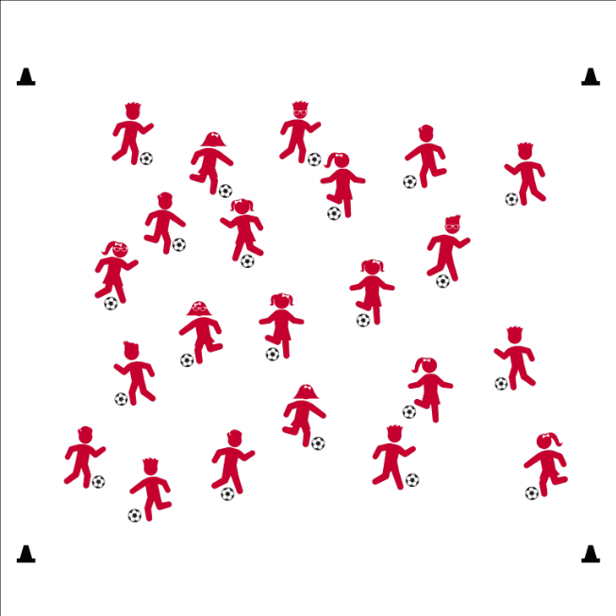
SCRAMBLE
- Skill: I will demonstrate control of ball and body by dribbling within the activity area boundaries.
- Cognitive: I will identify the components of health- and skill-related fitness developed by participating in Scramble.
- Fitness: I will increase my heart rate by participating in Scramble.
- Personal & Social Responsibility: I will identify ways that I can exhibit personal responsibility during a game of Scramble.

- Ears Alert
- Eyes Up
- Quick Looks
- Inside/Outside Taps

Grade Level Progression:
3rd: Dribble at a walking pace.
4th: Dribble at a jogging pace.
5th: Dribble at a jogging pace, using signals for changing speed and direction.

Challenge Progressions:
Call out, “Double Scramble.” Students must quickly move and tap a new ball, and then move and control a second ball.

Modifications:
Play Scrambled Bases by providing each student a poly spot or low profile cone. Students begin at a base. When they hear “Scrambled Bases,” they must dribble to a new base.

Equipment:
- 4 large cones
- 1 soccer ball per student

Set-Up:
- Create boundaries for a large activity area with large cones.
- Scatter all students throughout the area, each with a ball.

Activity Procedures:
- This activity is called Scramble. On the start signal, begin dribbling in open space. When you hear “Scramble!” stop your Scatter all students throughout the area, each with a ball.
- Scatter all students throughout the area, each with a ball.





Dribble, General Space, Open Space, Ball Control, Body Control, Skill-related Fitness, Health-related Fitness

- Standard 1 [E18.3-4] Dribbles with the feet in general space at slow to moderate jogging speed with control of ball and body (3); Dribbles with the feet in general space with control of ball and body while increasing and decreasing speed (4).
- Standard 2 [E1. 3-5] Recognizes the concept of open spaces in a movement context (3); Applies the concept of open spaces to combination skills involving traveling (e.g., dribbling and traveling) (4a); Dribbles in general space with changes in direction and speed (S2.E1.4c); Combines spatial concepts with locomotor and non-locomotor movements in games environments (5).
- Standard 3 [E3.3-5] Describes the concept of fitness and provides examples of physical activity to enhance fitness (3); Identifies the components of health-related fitness (4); Differentiates between skill-related and health-related fitness (5).
- Standard 4 [E1.3&5] Exhibits personal responsibility in teacher-directed activities (3); Engages in physical activity with responsible interpersonal behavior (e.g., peer to peer, student to teacher) (5).
- Standard 5 [E1.3-5] Discusses the relationship between physical activity and good health (3); Examines the health benefits of participating in physical activity (4); Compares the health benefits of participating in selected physical activities (5).

- DOK 1: Can you remember the cues for foot dribbling?
- DOK 2: How did your ability to make quick looks around the activity area affect your success in Scramble?
- DOK 3: What are the steps you took in the process of moving from one ball to the next?
- DOK 1: How can you recognize personal responsibility? What might it look like in a game of Scramble?
- DOK 2: Let’s list all of the things we know about personal responsibility.
- DOK 3: What would the activity environment look like if several students acted irresponsibly toward their peers? What previous knowledge or experiences led you to that prediction?

Manage response rates with tiered questioning techniques: Lead debrief sessions with questions that have increasing cognitive complexity in order to promote deeper thinking about the content. Provide adequate time for all students to process and respond to each question, first in small groups, and then as a class. Require students to support their answers with evidence.

SCRAMBLE

